**DDI Metadata Production Exercise Using Nesstar Publisher**

* In Windows: Open nesstar publisher
  + Start -> All Programs -> Nesstar -> Nesstar Publisher
* In Nesstar Publisher:
  + File -> Import Study…
    - In window that opens, navigate:
      * Click on the “Computer” icon
      * Under Network Location (1) -> spdata (\\icpsr-semi-nas) (Z:)
      * Navigate to and click on -> humphrey -> 2012
    - Double Click on file: GSSC2_ICPSR2012.sav

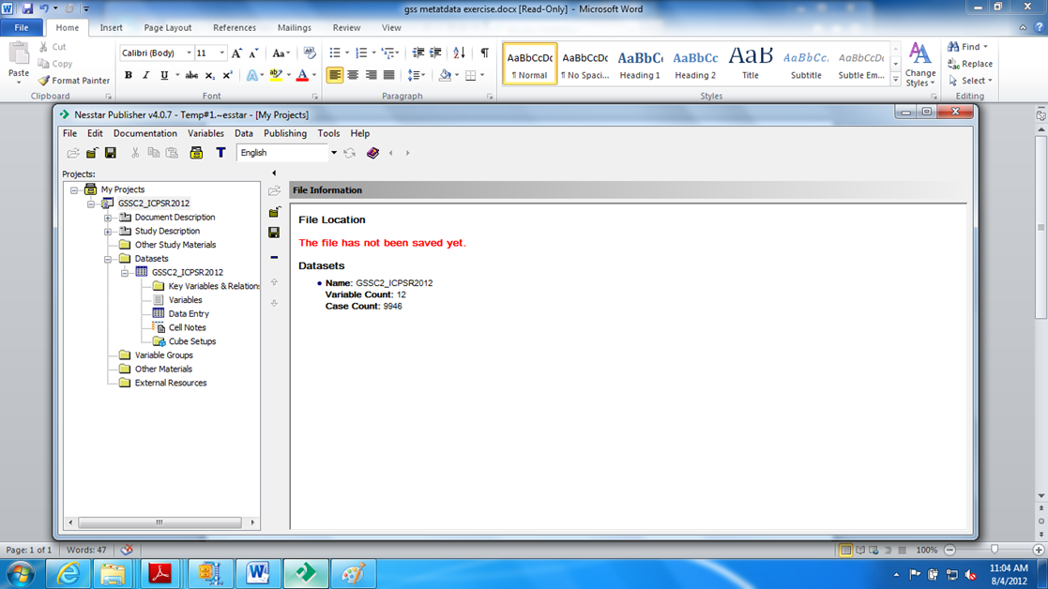

**Document Description**

* Open the options under “Document Description” by clicking on the Plus-Box. There are three categories of Citation that have multiple entry fields. Under each of these fields, you can obtain help by clicking on the field name. Note that the fields with the DC icon are Dublin Core elements and the little R is for required.
* Click on “Citation – Title Statement.” In the text box for Title, enter: General Social Survey Time Use, 1986
* In the text box for ID Number, enter: GSS1986
* Complete the text for the Authoring Entity under Responsibility Statement using your name and affiliation

**Study Description**

* Open the options under “Study Description” and click on “Citation.” We will be entering what appears to redundant fields but this information belongs to the data from the study it was produced rather than the documentation being prepared.
* Click on “Citation” (under Study Description) and enter in the Title textbox: General Social Survey, 1986[your last name]
* In ID Number, enter: GSS[your workstation number]
* In the Authoring field, enter in Name: Statistics Canada
* In the Distributors field, enter in Name: Data Liberation Initiative
* Open the options under “Scope – Subject Information.” Go to the Statistics Canada website at <http://TinyURL.com/gssabst> and use the information from this catalogue entry to complete the following fields.
* Locate the five SUBJECTS headings on the Statistics Canada webpage and using the Keywords field, enter each of these five subjects in the Text column. As you enter them, type Statistics Canada in the Vocabulary column.
* Enter the description from the website in the Abstract field.
* Use the target population text to complete the Universe field.
* Copy the sampling information into the Sampling Procedure field.

**Datasets**

* Open the options under “Datasets” and click on Variables. In this section, you will add value labels, indicate missing values, identify the weight variable and choose the statistics to be displayed with each variable (optional).

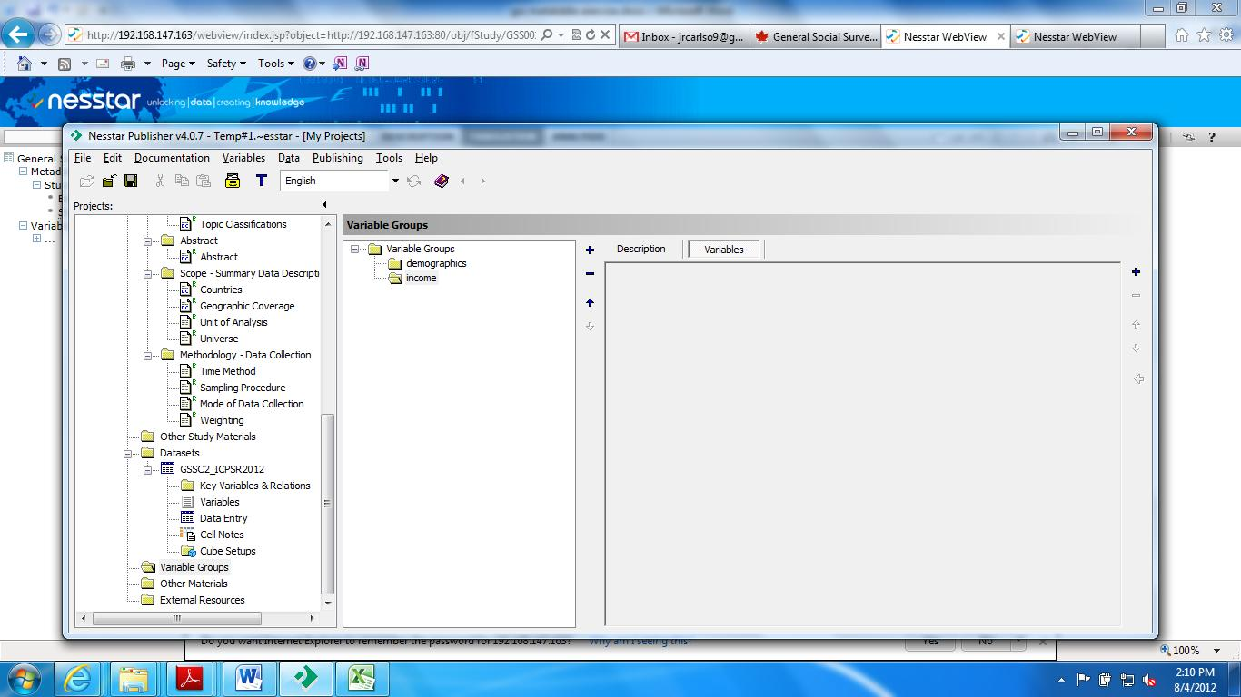

**Variable Groups**

* Click on the Variable Groups folder. Working from left to right in the Variable Groups frame, you will find an open folder. In the “Label” field, enter: Demographics.
* Click on the Variables tab and click on the + sign on the far right. This will open a text box with all of the variables. Holding the Control Key down, click on DVSEX, DVAGE1, DVLANG, DVEDR and DVCHILD. Then click OK.
* Click on Variable Group Folder to go to the top of the hierarchy and then click on + sign to the left of “Description.” Click on Description and enter in the label text box: Income.
* Click on the Variables tab and click on the far right + sign. Add DVTOTINC and HOUSINC3 and OK.
* Create a new Variable Group folder and name it “Time Use Activities.” Click + for variables and add DURAC_01, DURAC_20 and DURAC_21.
* Again create a new Variable Group folder and it “Happy.” Click + and add HAPPY_E1.
* One last Variable Group, create and call it “Admin.” Put the variables SEQNUM and FWGT_MS.

**Publishing to the Nesstar Server**

* Select “Publishing” from the menu bar and select “Add Server…”. The server address is 192.168.147.163 . Complete the following text box using your name instead of Chuck’s. Your ID is your first name and last name’s initial, all in lowercase. Your password is Dataservices

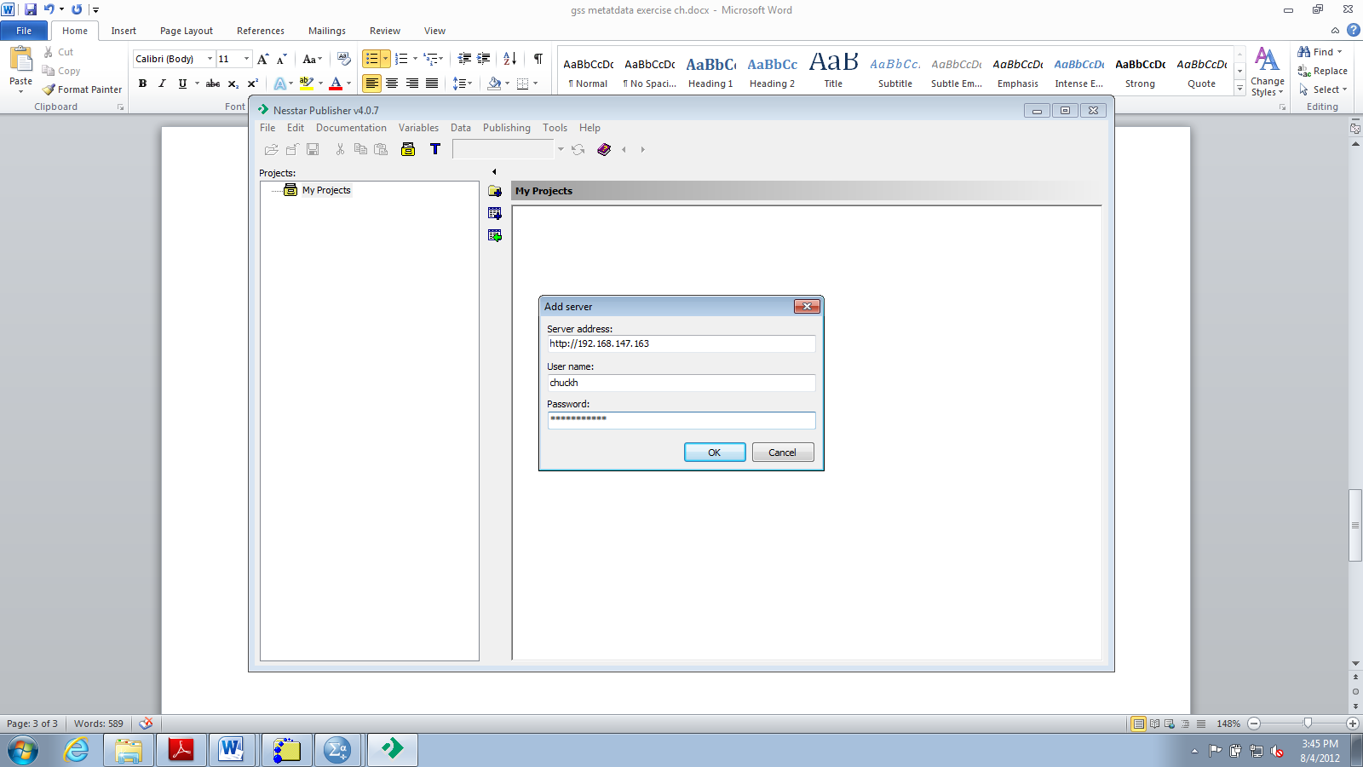

* This is a one-time task.
* A new text box is opened with the file structure of the Nesstar Server. We have already created a folder for your data named ICPSRSPN. Click on the name of this folder. The sequence is to click “Publishing,” “The ICPSRSPN server,” “Study,” “Publish data and metadata…”.

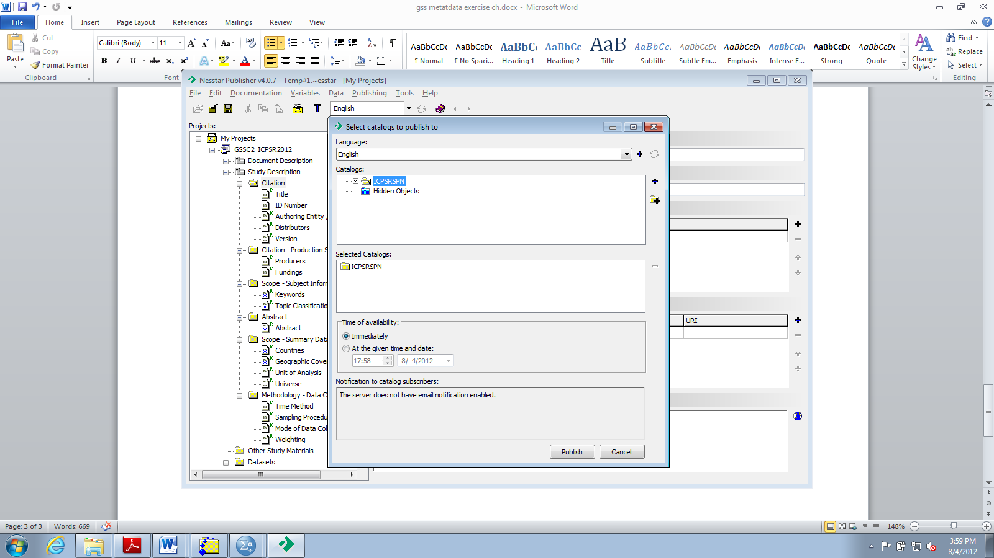

* The first time that you publish a survey title to the Nesstar server, you will encounter the above text box. Click the open check-box next to the folder named “ICPSRSPN.” Then click on Publish.

**Using your published data**

* In Windows, go to Start -> All Programs -> Internet Applications -> Google Chrome.
* Open http:// 192.168.147.163 to see your study on the Nesstar Server.
* Click on the plus sign to see all the studies
* Click on the plus sign next to the study you created.